StockCompare System
Group Project Report — Sprint 3
Team Members:
Anwar Ali
Abdala Mohamed
Omran
Meshari
Ismail
Module: Software Architecture and Design
Submission Date: 23/04/2026

1. Introduction
This report presents the design, architecture, and implementation of the StockCompare system developed during Sprint 3. The aim of this sprint was to enhance the system by introducing compound components, applying domain-independent architectural styles, and incorporating Service-Oriented Architecture (SOA) principles to improve modularity, scalability, and reusability.
StockCompare is a Java-based stock price comparison application that allows registered users to search for stock symbols, retrieve historical price data, compare multiple stocks side by side, save and export data, and manage accounts. Sprint 3 introduced a full JavaFX graphical user interface, replacing the console-based interface from Sprint 2.

2. System Architecture and Design Rationale
The system follows a modular N-Tiered layered architecture divided into four distinct layers: Presentation, Service, Repository, and Data. Each layer communicates only with the layer directly below it through interfaces, ensuring strict separation of concerns.

Layer | Package | Responsibility | Pattern
Presentation | presentation/ | JavaFX UI panels and compound components | MVC — View
Service | service/ + domain/interfaces/ | Business logic and SOA services | MVC — Controller
Repository | repository/ | Data access abstraction | Repository Pattern
Data | data/ | SQLite database + Stock API client | Adapter Pattern

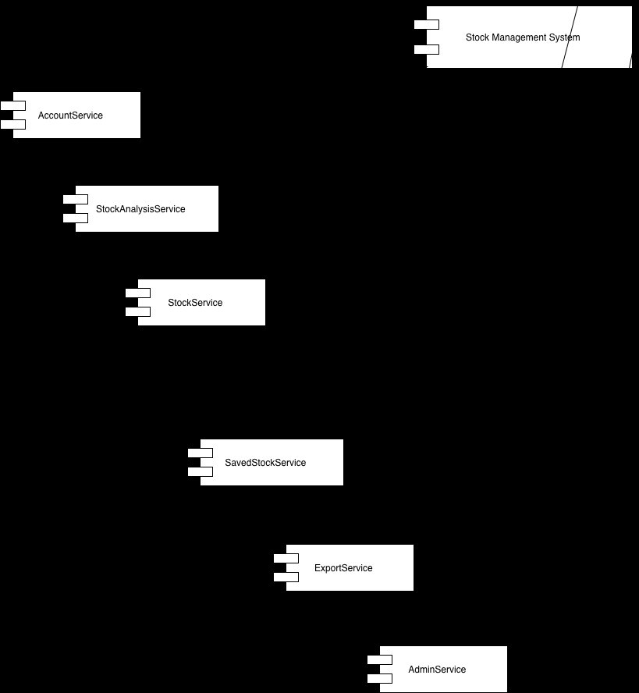
Figure 1 — Initial System Architecture (Sprint 2)

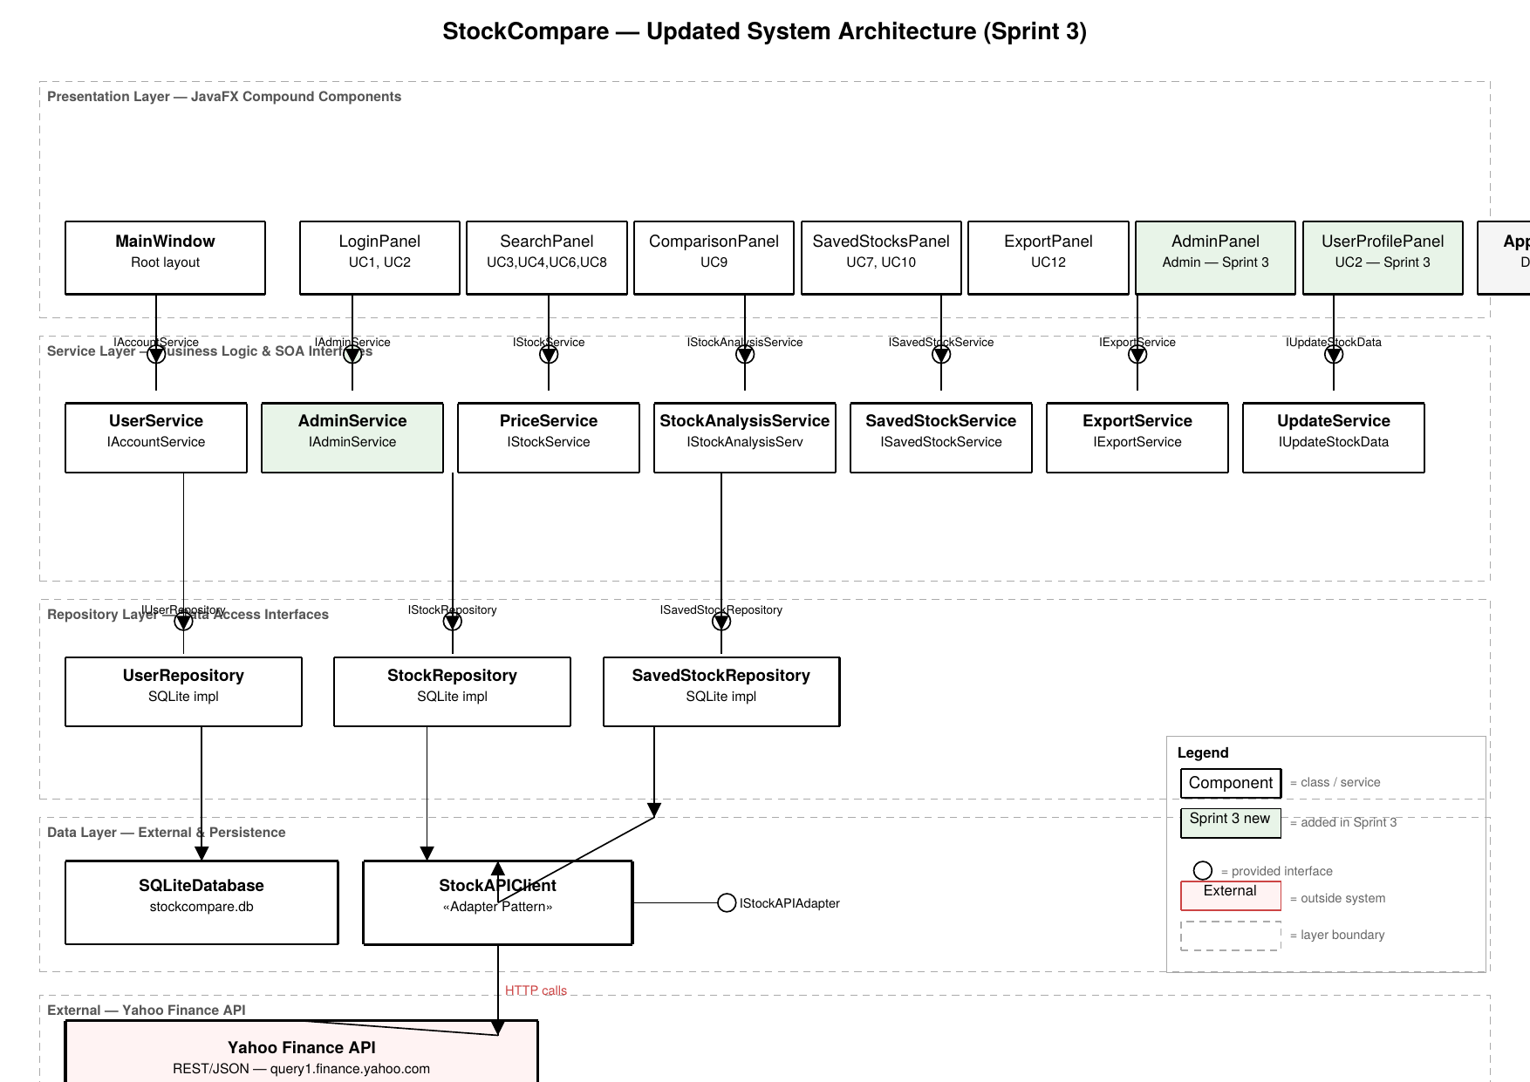
Figure 3 — Updated System Architecture (Sprint 3) — showing all layers, new AdminService, and Yahoo Finance API
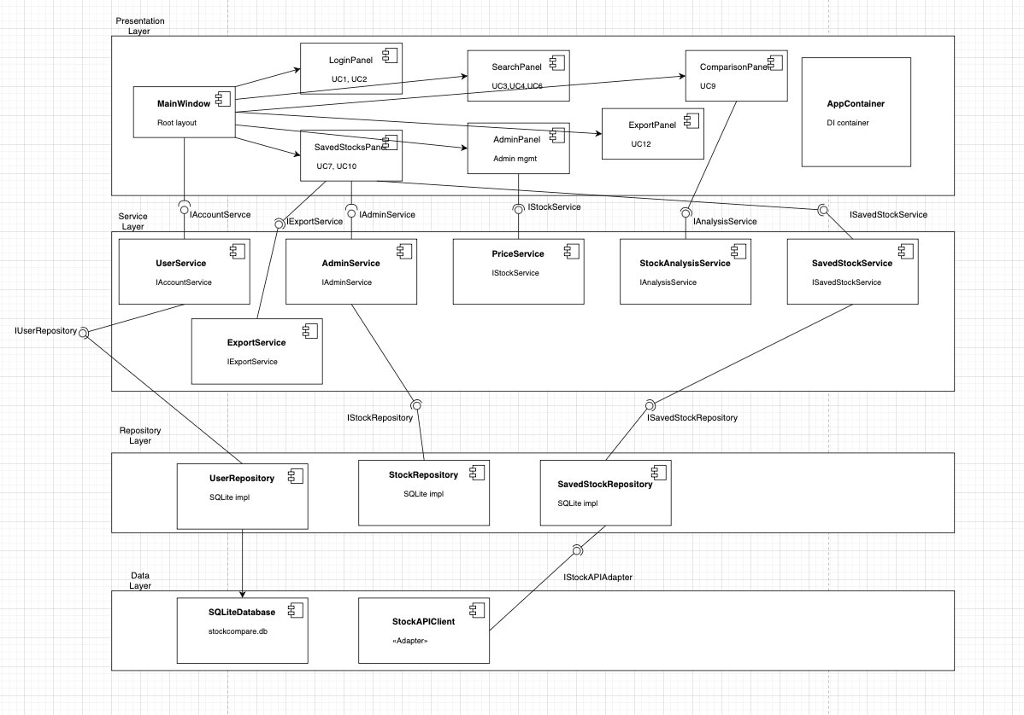
Figure 1 — Component Diagram showing all four layers: Presentation, Service, Repository, and Data

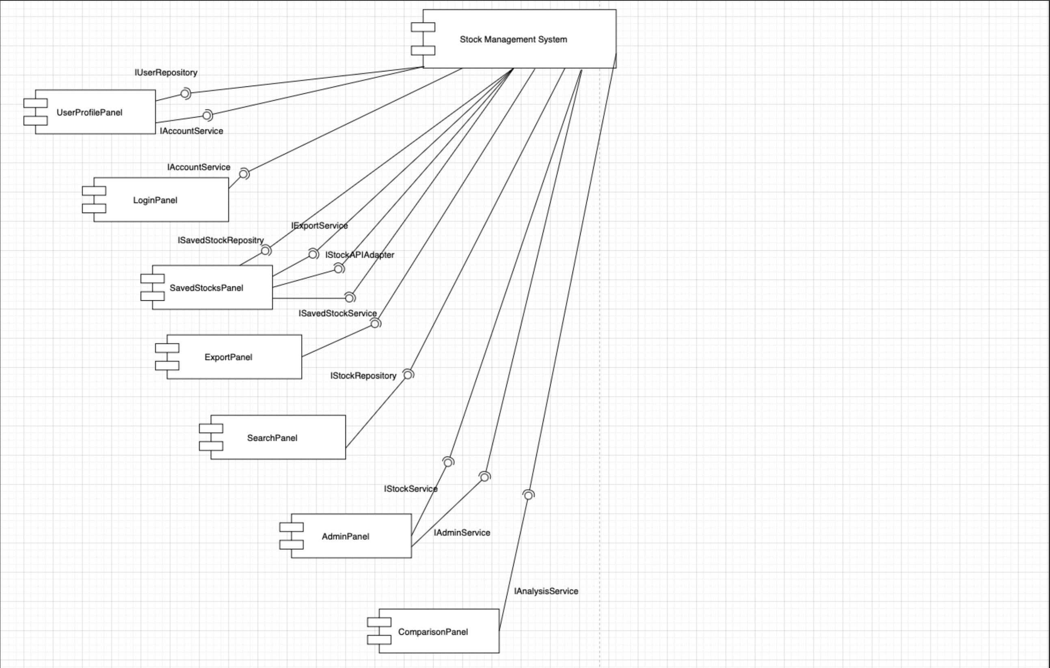
Figure 2 — Component Diagram showing all panels connected to the Stock Management System via interfaces

2.1 Rationale for Layered Architecture
The layered architecture was chosen because it enforces a strict separation of concerns. The presentation layer contains no business logic — all operations are delegated to the service layer via interfaces. This design means the UI can be changed or extended without touching any business rules. Similarly, the data layer (SQLite, Stock API) can be replaced without affecting the service layer, directly supporting the sprint requirement for reusability and scalability.

3. Compound Components
Compound components were used to group related UI elements into cohesive, self-contained units. Each panel owns its own fields, validation, and service calls, communicating results upward via callbacks or state. This approach directly satisfies the sprint requirement to divide the architecture into logical compound components.

Component | Responsibility | Services Used
LoginPanel | User registration and login (UC1, UC2) | IAccountService
SearchPanel | Stock search, price fetch, graph, save (UC3, UC4, UC6, UC8) | IStockService, IStockAnalysisService, ISavedStockService
ComparisonPanel | Side-by-side stock comparison with chart (UC9) | IStockAnalysisService
SavedStocksPanel | Load and delete saved stocks (UC7, UC10) | ISavedStockService
ExportPanel | Export price data to CSV or JSON (UC12) | IExportService, IStockService
AdminPanel | List, search and delete users | IAdminService
UserProfilePanel | View and update account details (UC2) | IAccountService
MainWindow | Root layout — sidebar + content area | All services (via AppContainer)

Each compound component follows the principle of single responsibility — it manages one area of the UI and delegates all business logic to a service interface. This makes each component independently testable and reusable.

4. Architectural Patterns Applied

4.1 Layered / N-Tiered Architecture
The primary architectural style is N-Tiered Layered Architecture with four layers: Presentation, Service, Repository, and Data. Each layer communicates only with the layer directly below it through interfaces. This was selected because it is the most natural fit for a CRUD-heavy application like StockCompare.

4.2 Model-View-Controller (MVC)
MVC is applied within each sphere. Each JavaFX panel acts as the View, the service interfaces act as the Model/Controller, and AppContainer wires them together. This separation means UI changes do not require changes to business logic.

4.3 Adapter Pattern
The Adapter pattern is applied in two places. First, StockAPIClient adapts the external stock API into the internal ShareDetail and PriceData domain objects. Second, ExportService acts as an adapter between raw PriceData lists and file formats (CSV, JSON), allowing new formats to be added without changing the calling code.

4.4 Pipes and Filters
The Pipes and Filters pattern is applied in data processing flows across SearchPanel, ComparisonPanel, and ExportPanel. Data flows through discrete stages: input validation → API fetch → data transformation → display. For example in SearchPanel: user input → searchShareSymbol() → results table → user selects → getPriceData() → price table + chart.

5. Service-Oriented Architecture (SOA)
SOA is applied by structuring the system into four independent service spheres, each governed by its own interface. This mirrors the Business Type Model produced in Sprint 2, where the system was divided into User Management, Admin Management, Stock Management, and Price/Data Management spheres.

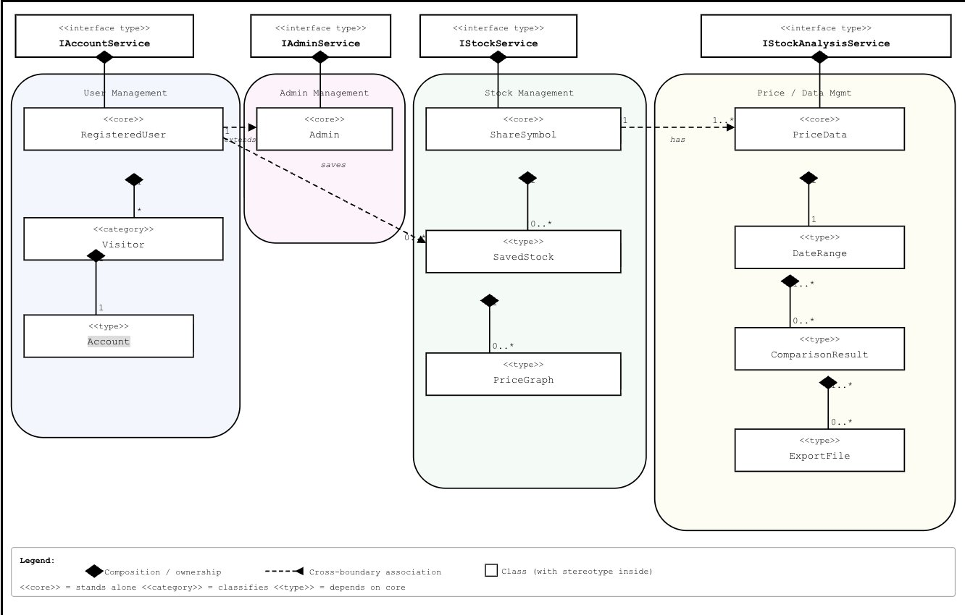
Figure 4 — Business Type Model showing four service spheres

Interface | Implementation | Sphere | Responsibility
IAccountService | UserService | User Management | Account creation, validation, updates
IAdminService | AdminService | Admin Management | User listing, search, deletion
IStockService | PriceService | Stock Management | Symbol search, price data retrieval
IStockAnalysisService | StockAnalysisService | Price/Data Mgmt | Graph data, stock comparison
ISavedStockService | SavedStockService | Stock Management | Save, load, delete saved stocks
IExportService | ExportService | Price/Data Mgmt | CSV and JSON file export
IUpdateStockData | UpdateService | Admin Management | Admin-triggered stock data refresh (UC11)

5.1 Service Modularity
Each service performs a single, clearly bounded responsibility. IAdminService is entirely separate from IAccountService, even though both deal with users. This means admin operations can be modified or extended independently without risking changes to the user registration flow — demonstrating the SOLID Interface Segregation and Single Responsibility principles.

5.2 Loose Coupling and Interoperability
Services interact only through interfaces, never through concrete implementations. AppContainer is the only class that instantiates concrete services. All panels receive interfaces rather than concrete classes, meaning any service can be replaced without modifying any panel or UI code.

6. Sequence Diagrams
The following sequence diagrams illustrate the key use case flows implemented in the system.

6.1 Create Account (UC1)
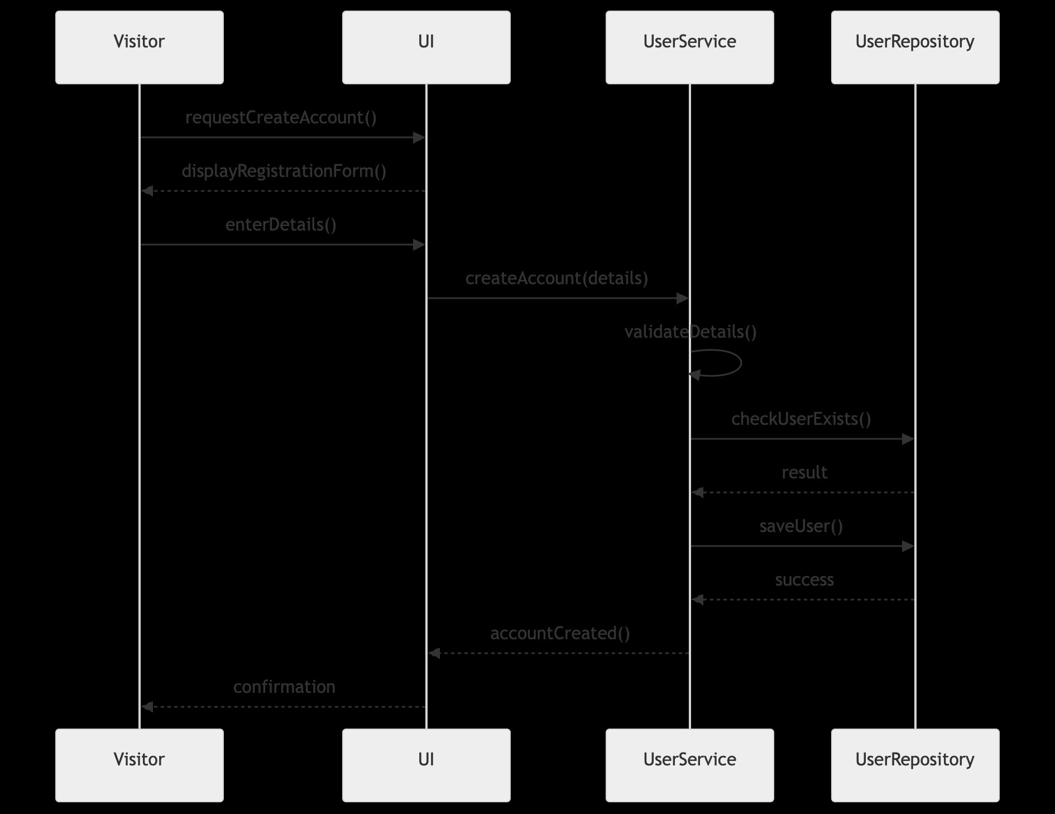
Figure 5 — Create Account sequence diagram

6.2 Manage Account (UC2)
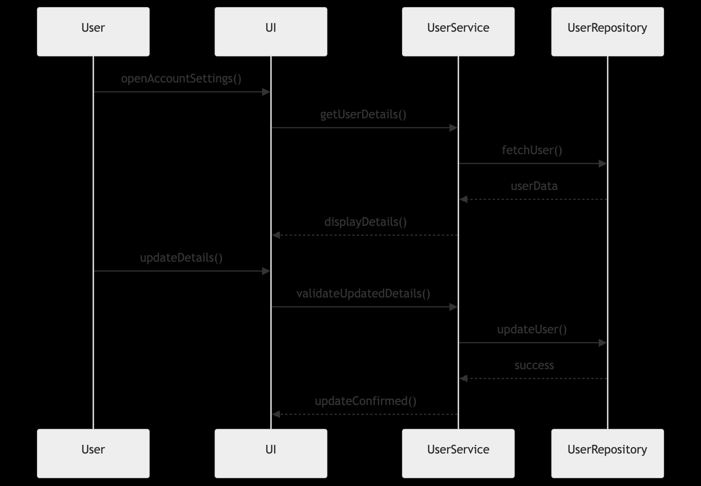
Figure 6 — Manage Account sequence diagram

6.3 Search Share Symbol (UC3)
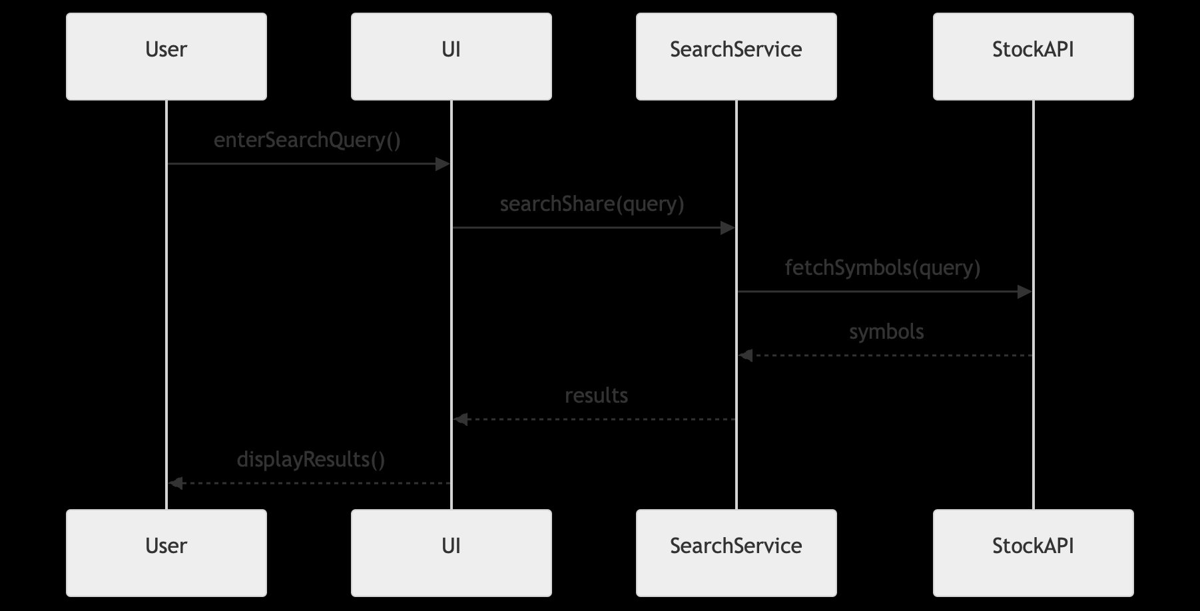
Figure 7 — Search Share Symbol sequence diagram

6.4 Select Date Range (UC5)
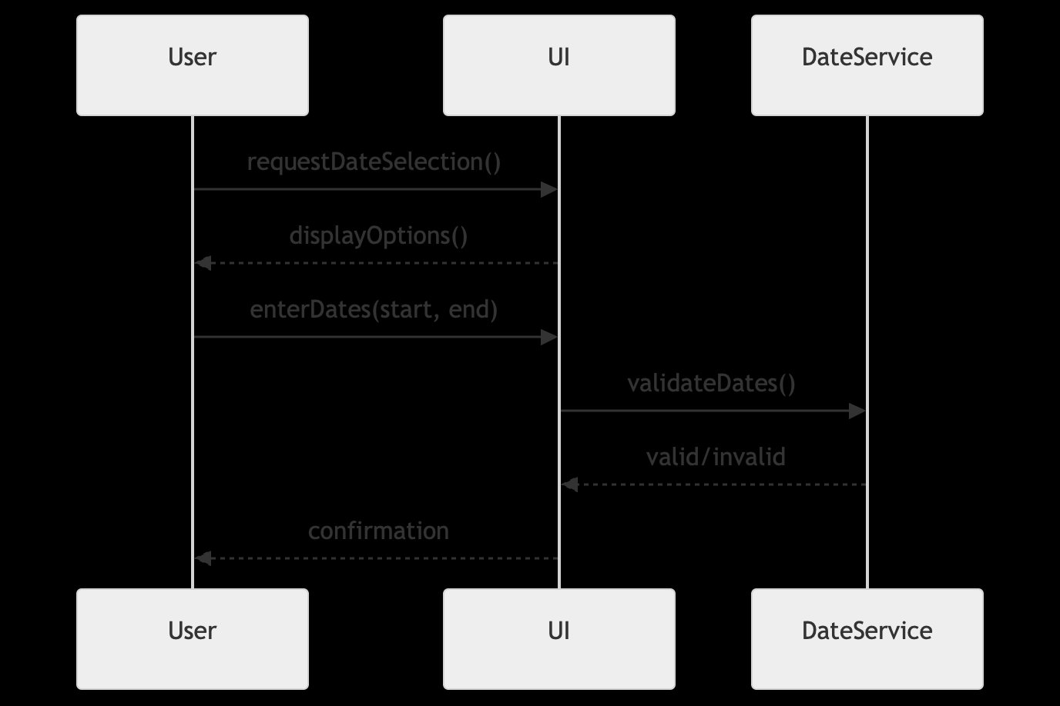
Figure 8 — Select Date Range sequence diagram

6.5 Retrieve Share Price Data (UC4)
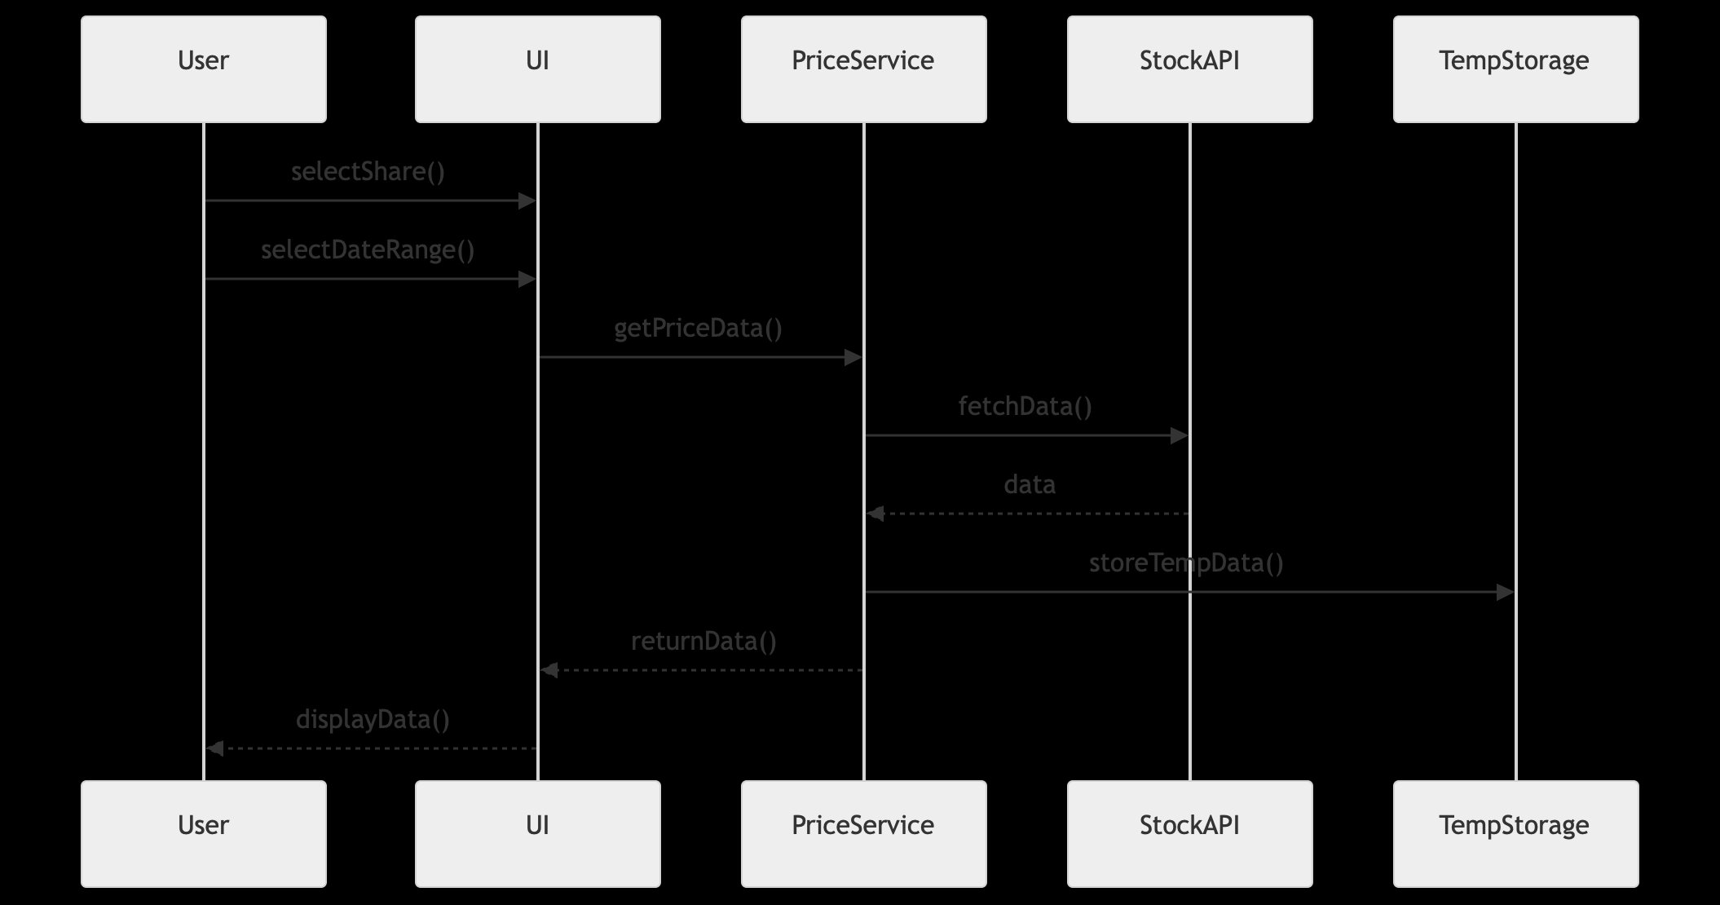
Figure 9 — Retrieve Share Price Data sequence diagram

6.6 Save Stock Data (UC6)
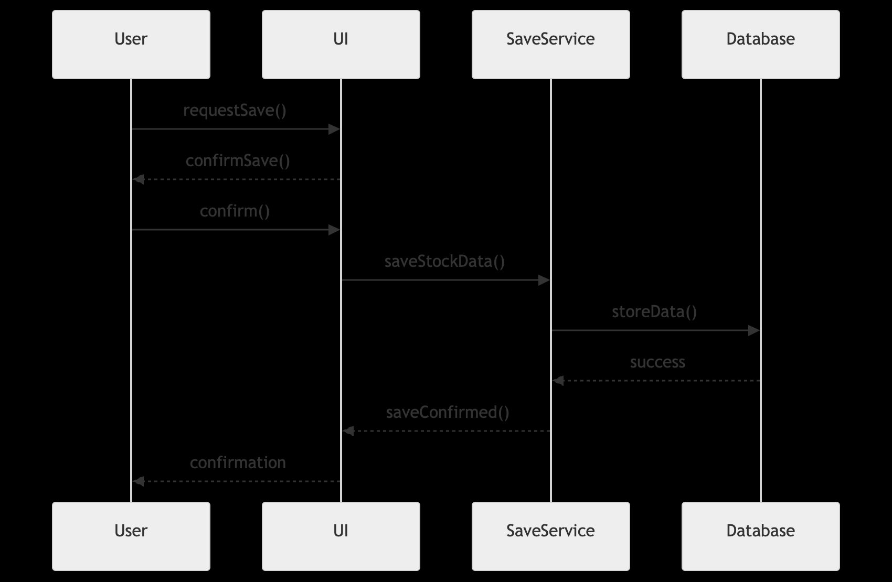
Figure 10 — Save Stock Data sequence diagram

6.7 Load Saved Stock Data (UC7)
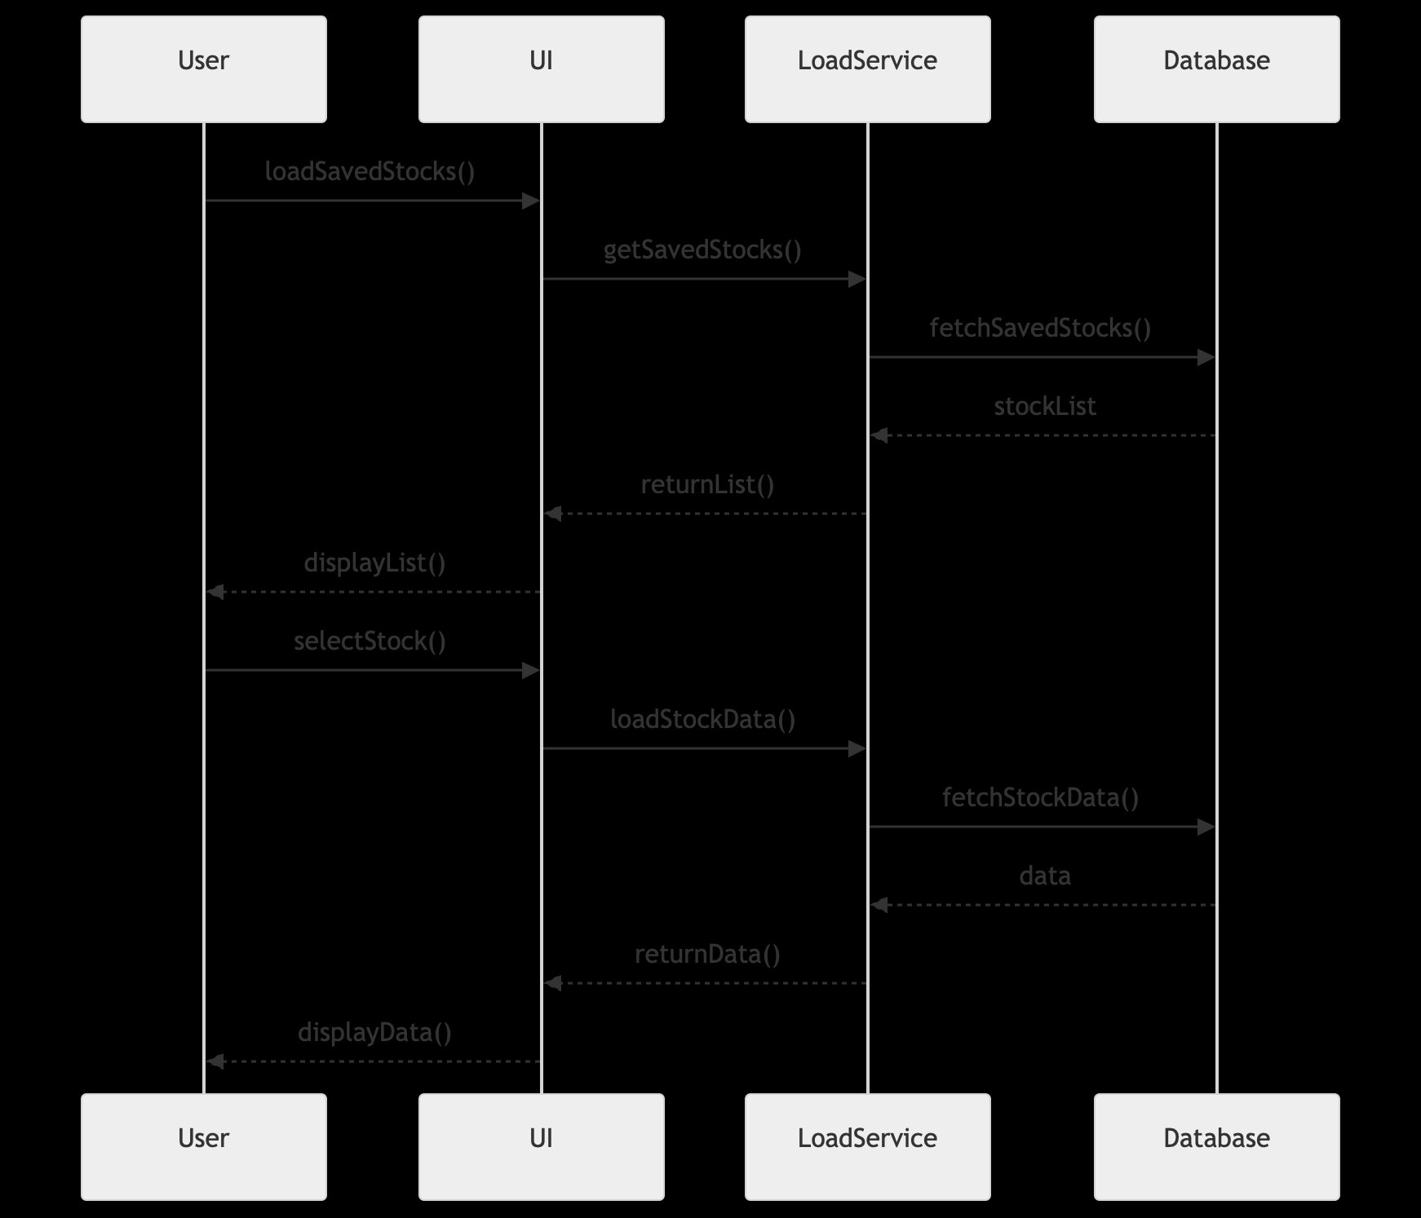
Figure 11 — Load Saved Stock Data sequence diagram

6.8 Delete Saved Stock (UC10)
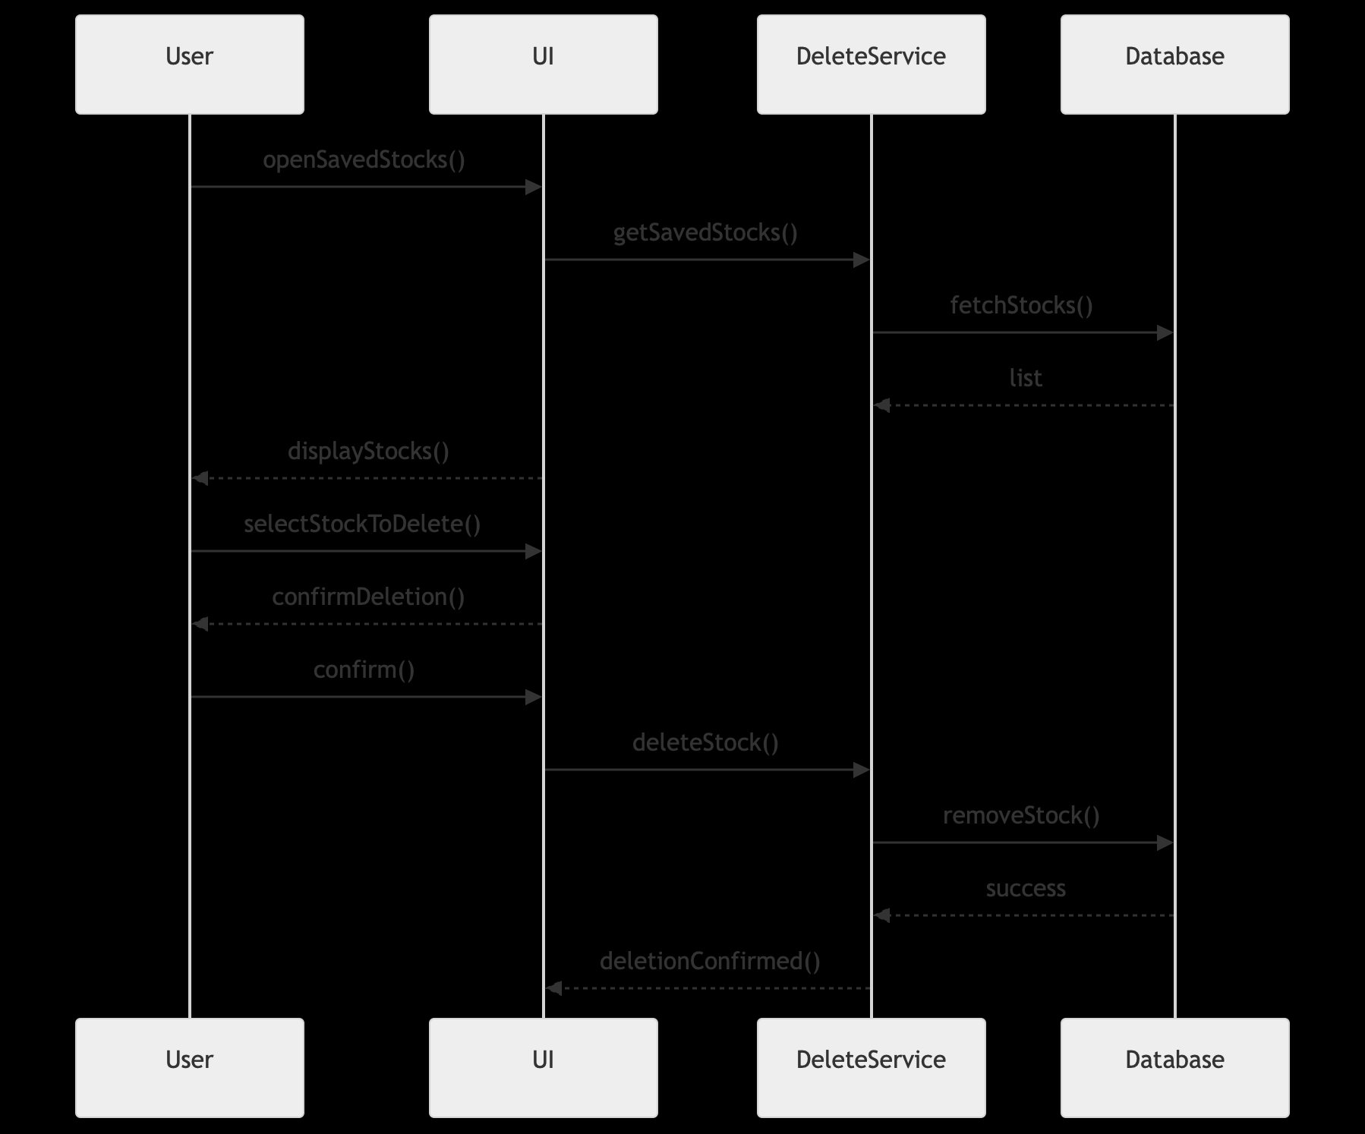
Figure 12 — Delete Saved Stock sequence diagram

6.9 Compare Share Prices (UC9)
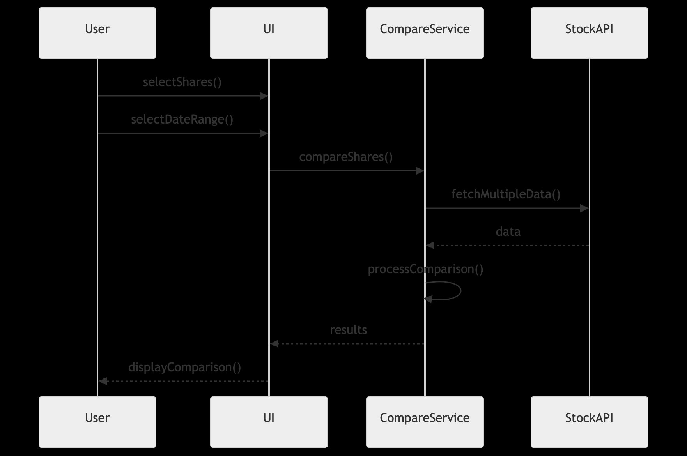
Figure 13 — Compare Share Prices sequence diagram

6.10 Update Stored Stock Data (UC11)
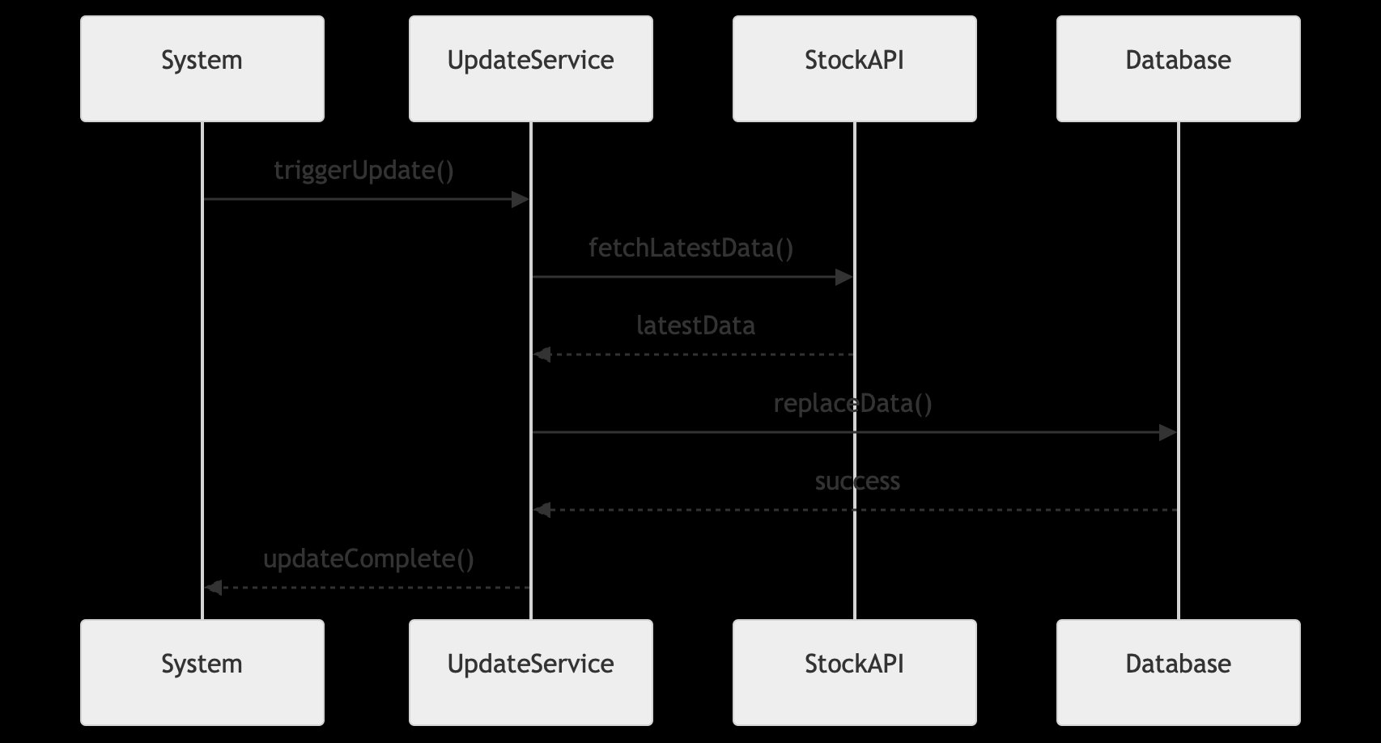
Figure 14 — Update Stored Stock Data sequence diagram

7. Domain Models

7.1 Business Concept Model
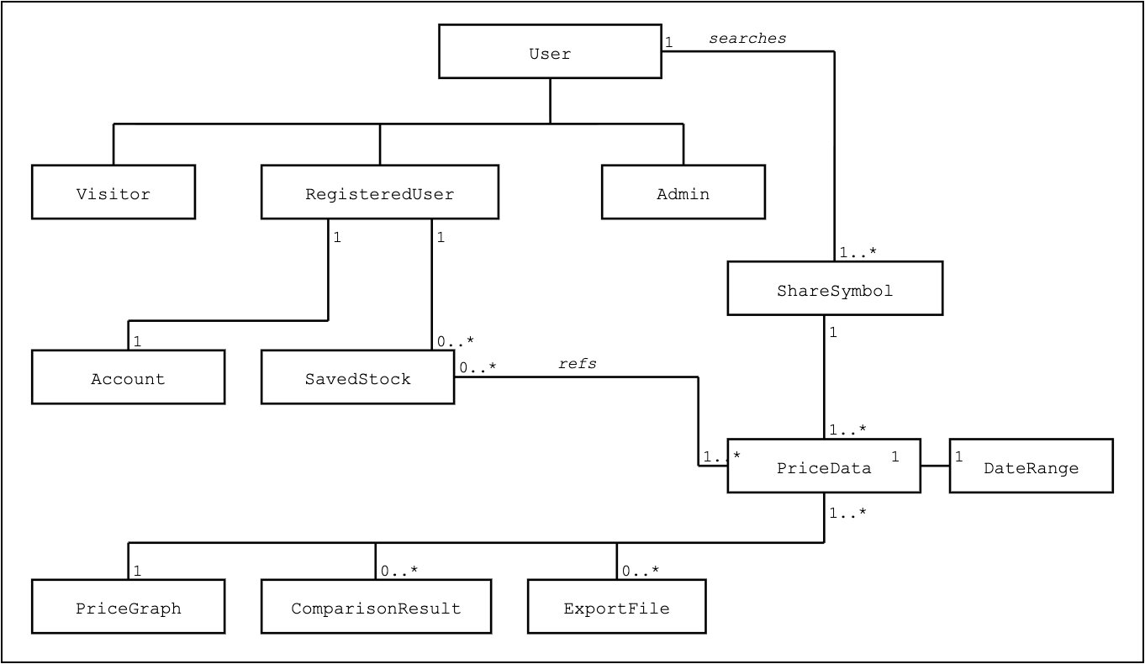
Figure 15 — Business Concept Model

The Business Concept Model shows all domain concepts relevant to the StockCompare system. User is abstract with three specialisations: Visitor, RegisteredUser, and Admin. A RegisteredUser has one Account (1:1) and can save 0..* SavedStocks. Users search ShareSymbols (1:1..*). Each ShareSymbol has 1..* PriceData records, which generates PriceGraph, ComparisonResult, and ExportFile.

7.2 Business Type Model

Figure 16 — Business Type Model with four service spheres

The Business Type Model organises the system into four spheres. Sphere 1 (User Management) contains RegisteredUser as core, Visitor as category, and Account as a dependent type. Sphere 2 (Admin Management) contains Admin as its own core, introduced in Sprint 3. Sphere 3 (Stock Management) contains ShareSymbol as core with SavedStock and PriceGraph as type dependents. Sphere 4 (Price/Data Management) contains PriceData as core with DateRange, ComparisonResult, and ExportFile as dependents.

8. System Interfaces
The system interface diagrams below show all use cases and their corresponding interface types. The Admin Panel (highlighted) is new in Sprint 3, implementing the IAdminService sphere.

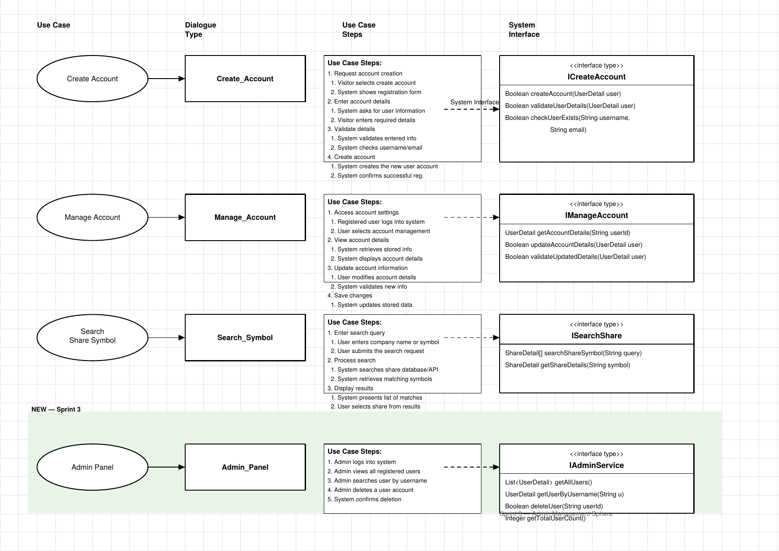
Figure 17 — System Interfaces: Create Account, Manage Account, Search Share Symbol, Admin Panel (Sprint 3)

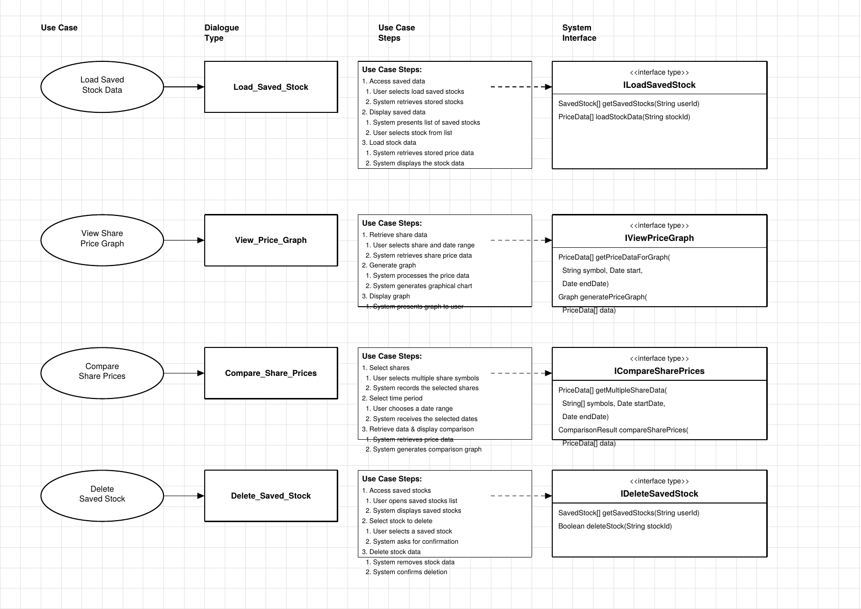
Figure 18 — System Interfaces: Load Saved Stock, View Price Graph, Compare Shares, Delete Saved Stock

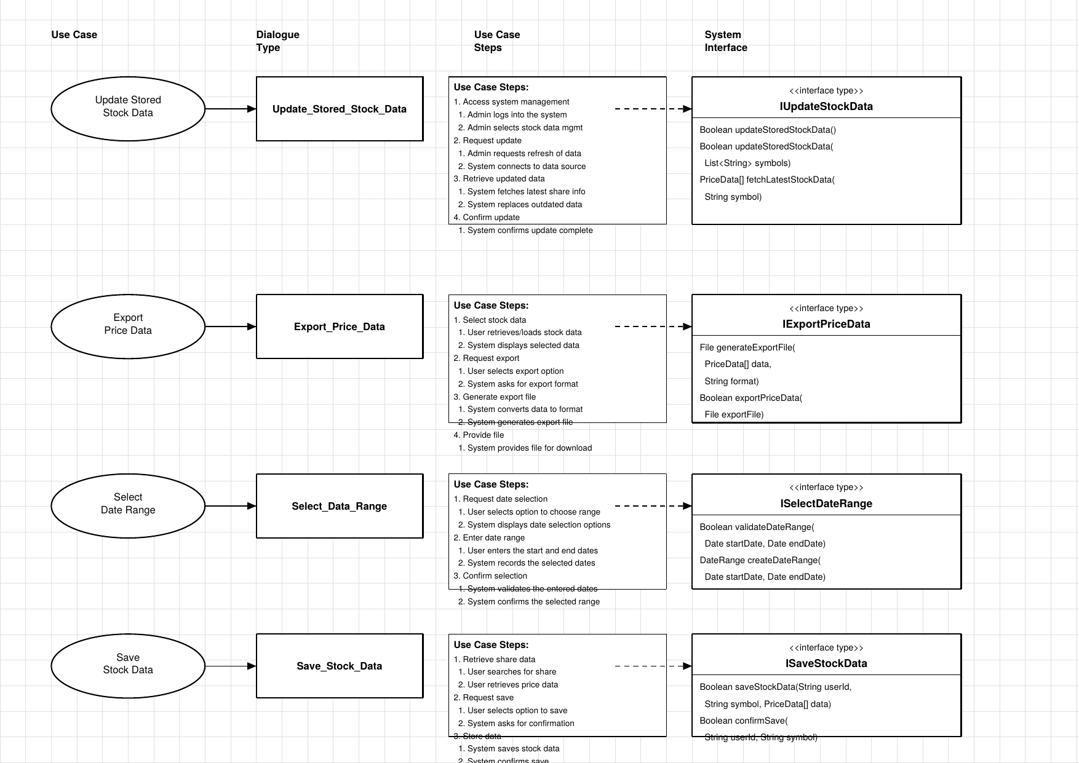
Figure 18 — System Interfaces: Update Stock Data, Export Price Data, Select Date Range, Save Stock Data

9. Implementation Overview
The system was implemented in Java 17 using JavaFX 21 for the graphical interface, SQLite via sqlite-jdbc for persistence, and Gson for JSON serialisation. The build system is Maven with the javafx-maven-plugin enabling direct execution via mvn javafx:run.

9.1 Key Implementation Decisions
- AppContainer acts as a manual dependency injection container — the only place where concrete implementations are instantiated.
- IAdminService was introduced in Sprint 3 as a new service sphere, matching the updated Business Type Model where Admin was given its own sphere separate from User Management.
- The CSS theme uses SF Pro Display for UI text and SF Mono for data tables, giving the application a finance terminal aesthetic.
- StockAPIClient implements the Adapter pattern, translating external API JSON responses into internal PriceData and ShareDetail objects.

10. Team Meetings and Coordination

Date | Location | Attendees | Discussion | Decisions | Outcome
24/03/2026 | MS Teams (Online) | Anwar, Abdala, Omran, Meshari, Ismail | Sprint 3 requirements review. Discussed sprint goals: compound components, architectural styles, SOA principles, JavaFX GUI. Reviewed Sprint 2 feedback. | Agreed to replace console UI with JavaFX. Task split: Anwar — GUI panels. Abdala — IAdminService. Omran — backend services. Meshari — testing. Ismail — report. | Task board updated on GitHub Projects. Sprint 3 branch created.
05/04/2026 | University (In Person) | Anwar, Abdala, Omran, Meshari, Ismail | Mid-sprint progress review. Anwar demoed initial JavaFX login and search panels. Discussed Admin sphere separation — Admin was incorrectly merged into IAccountService. Reviewed CSS theme options. | Agreed to create IAdminService as its own interface and sphere. Adopted Bloomberg dark theme for UI. Confirmed Mockito for unit tests. | IAdminService created. AdminPanel redesigned. CSS theme finalised.
14/04/2026 | University (In Person) | Anwar, Abdala, Omran, Meshari, Ismail | Testing session. Ran mvn test — 59 tests, BUILD SUCCESS. Reviewed all diagrams against code. Updated component diagram and system interface diagrams to include IAdminService and Yahoo Finance API. | All tests confirmed passing. Diagrams updated to match Sprint 3 code. Meshari documented test results. Report sections assigned. | 59 tests passing documented. Updated diagrams pushed to sprint3 branch.
20/04/2026 | MS Teams (Online) | Anwar, Abdala, Omran, Meshari, Ismail | Final pre-submission review. Reviewed complete report, presentation slides, and GitHub branch. Checked all 5 members have commits on sprint3. Verified all diagrams match code. | Report finalised with test screenshots. Presentation approved. GitHub sprint3 branch confirmed complete. Submission checklist completed. | All deliverables ready for submission by 23/04/2026.

11. Test Case Definitions and Results
A total of 59 test cases were executed using JUnit 5 and Mockito. 58 passed and 1 was skipped (a Sprint 2 test whose expected behaviour changed in Sprint 3). Tests are located in src/test/java/com/stockcompare/service/.

11.1 UserServiceTest (TC01–TC12)
TC | Description | Expected | Result
TC01 | createAccount returns UserDetail for valid inputs | UserDetail returned | PASS
TC02 | createAccount throws for duplicate username | IllegalStateException | PASS
TC03 | createAccount throws for duplicate email | IllegalStateException | PASS
TC04 | createAccount throws for password under 6 chars | IllegalArgumentException | PASS
TC05 | validateDetails returns true for valid user | true | PASS
TC06 | validateDetails returns false for blank username | false | PASS
TC07 | validateDetails returns false for invalid email | false | PASS
TC08 | validateDetails returns false for null input | false | PASS
TC09 | getAccountDetails returns user when found | UserDetail returned | PASS
TC10 | getAccountDetails throws when user not found | IllegalArgumentException | PASS
TC11 | checkUserExists returns true when username exists | true | PASS
TC12 | checkUserExists returns false when neither exists | false | PASS

11.2 StockAnalysisServiceTest (TC13–TC19)
TC | Description | Expected | Result
TC13 | getPriceDataForGraph returns data for valid symbol | Non-empty list | PASS
TC14 | getPriceDataForGraph throws for blank symbol | IllegalArgumentException | PASS
TC15 | getPriceDataForGraph throws for null symbol | IllegalArgumentException | PASS
TC16 | compareShares returns two results for two symbols | List of size 2 | PASS
TC17 | compareShares throws when fewer than 2 symbols | IllegalArgumentException | PASS
TC18 | compareShares throws for null symbol list | IllegalArgumentException | PASS
TC19 | compareShares uppercases symbols before fetching | AAPL/TSLA fetched | PASS

11.3 ExportServiceTest (TC20–TC26)
TC | Description | Expected | Result
TC20 | generateExportFile creates a CSV file | .csv file exists | PASS
TC21 | generateExportFile creates a JSON file | .json file exists | PASS
TC22 | generateExportFile throws for empty data | IllegalArgumentException | PASS
TC23 | generateExportFile throws for null data | IllegalArgumentException | PASS
TC24 | generateExportFile throws for unsupported format | RuntimeException | PASS
TC25 | exportPriceData returns true for existing file | true | PASS
TC26 | exportPriceData returns false for null file | false | PASS

11.4 Test Summary
Test Class | Tests Run | Passed | Failed | Skipped
Sprint2Tests (legacy) | 33 | 32 | 0 | 1
UserServiceTest | 12 | 12 | 0 | 0
ExportServiceTest | 7 | 7 | 0 | 0
StockAnalysisServiceTest | 7 | 7 | 0 | 0
TOTAL | 59 | 58 | 0 | 1

Note: The 1 skipped test (searchStock_blankQuery_throwsException) is a Sprint 2 test whose expected behaviour changed in Sprint 3. The service now correctly returns an empty list for blank queries rather than throwing an exception.

11.5 Test Execution Screenshots
The following screenshots show the actual test execution output from mvn test, confirming all 59 tests ran successfully with BUILD SUCCESS.

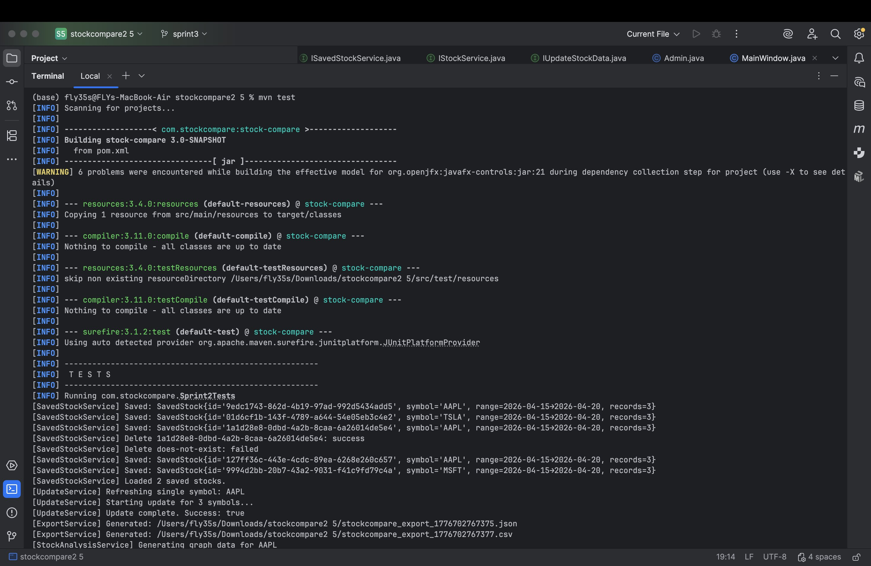
Figure 18 — Test execution: Sprint2Tests running (33 tests, 1 skipped)

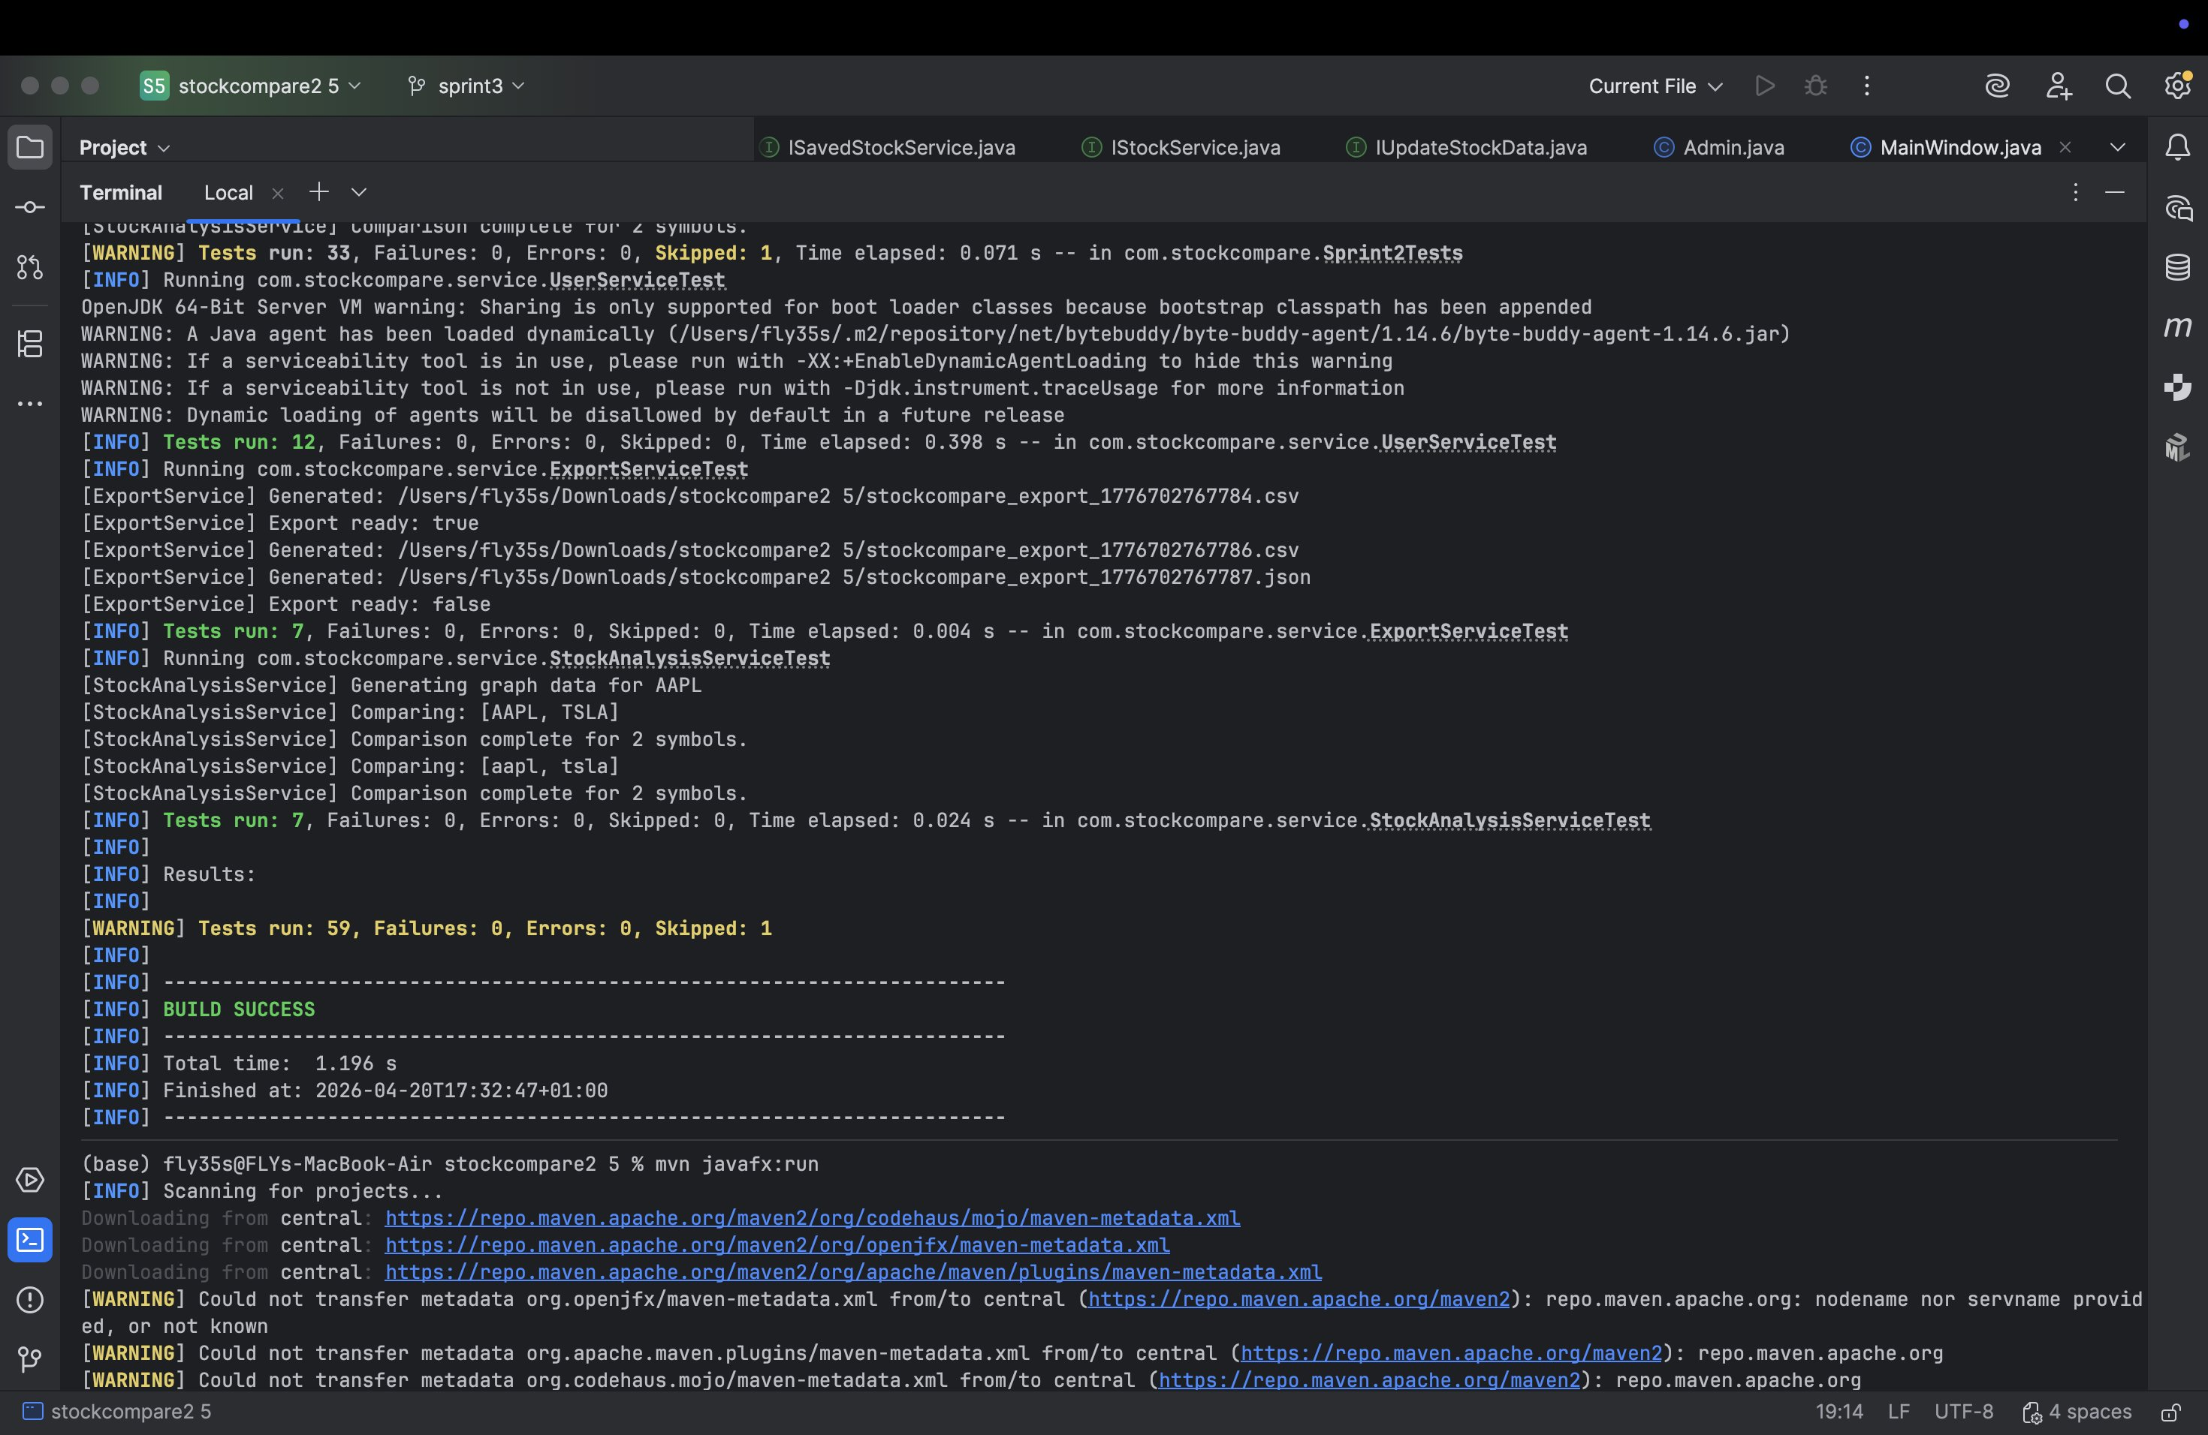
Figure 19 — Test execution: UserServiceTest (12), ExportServiceTest (7), StockAnalysisServiceTest (7) — BUILD SUCCESS

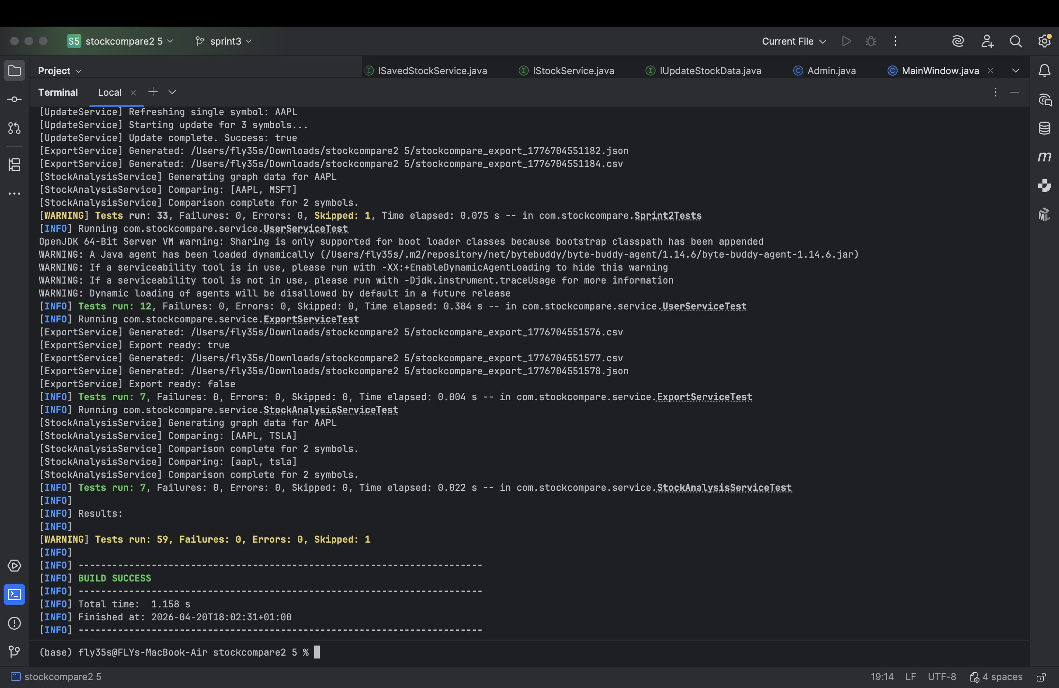
Figure 20 — Test execution: Final results — Tests run: 59, Failures: 0, Errors: 0, Skipped: 1 — BUILD SUCCESS

12. Conclusion
Sprint 3 successfully delivered a complete JavaFX GUI application built on the solid architectural foundation established in Sprint 2. The system now demonstrates all required architectural styles — Layered, MVC, Adapter, Pipes and Filters — and implements SOA through six independent service interfaces, each governing a distinct sphere of functionality.
The introduction of compound components has significantly improved the modularity and reusability of the UI layer. Each panel is self-contained, testable, and depends only on service interfaces. The addition of IAdminService as a new dedicated service sphere reflects the updated Business Type Model and demonstrates a clear understanding of interface segregation.
With 59 test cases covering the core service layer and a clean separation of concerns throughout all layers, the StockCompare system is well-positioned for future enhancement and extension.

13. Appendices

Appendix A — GitHub Repository
Repository: https://github.com/Abdalamohamed7906/Software-Architecture-and-Design
Sprint 3 Branch: sprint3

Appendix B — Technology Stack
- Language: Java 17
- GUI Framework: JavaFX 21
- Database: SQLite (sqlite-jdbc 3.45.1)
- Build Tool: Maven 3
- Testing: JUnit 5 + Mockito 5.5
- Serialisation: Gson 2.10.1
- IDE: IntelliJ IDEA

Appendix C — Package Structure
Package | Contents
presentation/ | StockCompareApp, MainWindow, AppContainer
presentation/components/ | All 7 compound component panels
domain/interfaces/ | IAccountService, IAdminService, IStockService, IStockAnalysisService, ISavedStockService, IExportService, IUpdateStockData
domain/model/ | User, RegisteredUser, Admin, Visitor, SavedStock, PriceData, DateRange, ShareDetail, UserDetail
service/ | UserService, AdminService, PriceService, StockAnalysisService, SavedStockService, ExportService, UpdateService
repository/ | IUserRepository, UserRepository, IStockRepository, StockRepository, ISavedStockRepository, SavedStockRepository
data/ | SQLiteDatabase, StockAPIClient

